# Section 1: Student Details

Full name: Matthew Ward

Student number: 1802599

Award / course: BSc (Hons) Computer Science

University Email address: M.Ward4@wlv.ac.uk

Supervisor: Jeffery Ting

Date of submission: 01/11/20

# Table of Contents

Section 1: Student Details 1

Table of Contents 2

Section 2: Statement of Project Details 3

2.1 Project Title 3

2.2 Academic Question 3

2.3 Aims 3

2.4 Objectives 3

2.5 Artefact (proposed) to be developed 3

Section 3: Project Proposal 4

3.1 Introduction 4

3.2 Initial Research into Sources of Information 4

3.3 Artefact (proposed) 4

3.4 Plan/Schedule 6

3.5 References and Bibliography 7

Section 4: Additional Sources of Information 8

4.1 Ethical Considerations Form 8

4.2 Resources 10

4.3 Client 10

# Section 2: Statement of Project Details

## 2.1 Project Title

Augmented Memory Mobile App

## 2.2 Academic Question

Could a speech recognition app for reminders be of benefit to those suffering from illness that affect memory.

## 2.3 Aims

* Research what exactly the effects conditions such as Dementia or Alzheimer’s can have on memory both short and long term
* Investigate pre-existing solutions as well as the tools that could be used to create an application of this sort
* Develop an Augmented Memory Mobile App prototype.
* Test and evaluate the prototype alongside voluntary participants.

## 2.4 Objectives

* Design a mobile application able to use user speech to create reminders.
* Develop the mobile app.
* Test the prototype with participants.
* Evaluate whether the prototype mobile application would be of any use to those suffering from memory-based conditions.

## 2.5 Artefact (proposed) to be developed

An app likely on Android that uses Java alongside Android text to speech/speech recognition in order to create reminders for the user. This can be stored on the device either using the notes or the built in SQL database on Android. This can later recalled on command or at a set time. Also, some general functionality using accelerometer to detect if the user has fallen over as well as the ability for easy contact of a nurse or 999/111 call. The application primarily will be used by the user to create reminders for themselves.

# Section 3: Project Proposal

## 3.1 Introduction

With the average lifespan of people ever increasing and more people are living into old age than ever before, conditions commonly associated with old age such as Alzheimer’s and Dementia are affecting more people who in turn struggle to manage day to day tasks by themselves as well as having issues in remembering information they may need.

This project will investigate how much a memory-based reminder app could benefit those suffering from memory related conditions, those who struggle to use new technology as well as the general population. It will take into consideration the design considerations for people who will find difficulty learning new tasks.

This project will start by researching into the effects of memory related conditions, difficulties faced by new and emerging technologies, how a world increasing in complexity may affect memory recollection alongside researching pre-existing solutions and the tools and languages that potentially could be used. A look at the potential of machine learning and Ai could also help with development.

Next will be the design and development of the application taking place. This will be done in either Android Studio in Java, cross platform with Flutter or on iOS using Swift. There will also be some need for utilising storage either with a SQL database or using simply the notes on the mobile device.

Finally, the project will end on testing the application with a range of participants in order to see the effectiveness of the reminders set by the application as well as see if there’s any potential for it to be used by those suffering from memory related conditions.

## 3.2 Initial Research into Sources of Information

For creating Apps within Android (Android Developers, 2019) using the official Android website seems to be the best starting place as it includes basic and more advanced coding tutorials, tools such as “Android Studio” which allow for creation of Android apps as well as relevant API which may be useful in the app’s development most notably “SpeechRecognizer”. The cost of developing on Android is free for own use apps or a one-time fee of $25 to place an app on the “Google Play Store”.

For information relating to designing apps on Apples own devices, a place to start would be the Swift developer site (Apple.com, 2019) for information on the language and how to use it within the code. However, this requires the use of a Mac computer and a fee of around $99 yearly.

For a more cross platform approach “Flutter” could instead be considered (Flutter.dev, 2019). This app created by Google can allow for apps to be designed to function on both iOS and Android and would likely be the method to go for if cross platform device use was the priority for this application.

The use of voice technology in reducing errors can be found in the “Journal of Organizational Behavior Management” (Berger and Ludwig, 2007). It evaluates how the use of voice technology can help reduce the number of errors employees typically make. This will likely be of importance when planning on implementing voice technology within the app.

When looking specifically at how technology may assist dementia the article “Technology in dementia care” (Cahill et al., 2007) looks at just how effective using technology may be in helping suffers of dementia, looking into this, it will be important in creating an application accessible to those with dementia as well as making sure it addresses their issues.

When looking more at the use of mobile phones within Alzheimer’s and Dementia “The role of M-health applications in the fight against Alzheimer’s: current and future directions” (Elfaki and Alotaibi, 2018) looks more specifically at how mobile technology such as smart phones may be of use with those with memory related illnesses and how it could improve their quality of life. As the aim of this project is to make a speech recognition memory app, seeing in which ways smartphones could be used will be of great importance.

Investigating pre-existing popular apps relating to the Artefact planned to be produced turned up an app named “Reminder, Reminder with Calendar and Voice Reminders” (Sergio Licea, 2020). This app uses pre recorded voice notes by the user to give a reminder about events at the time they set. It does however not seem to include speech recognition at all and can only play audio for notes the user recorded with their own voice.

Another app in use related to this project was “Lists To Do” (Thomas Tsopanakis, 2020). This app allows the user to create to do lists with notifications for any they still need to complete. This app was one of the most popular apps found on the “Apple App Store”, however similar to “Reminder, Reminder with Calendar and Voice Reminders” lacks any kind of speech recognition.

When looking at the differences in how age, gender etc. can have in the use of technology the article titled “Consumer Acceptance and Use of Information Technology: Extending the Unified Theory of Acceptance and Use of Technology” (Venkatesh, Thong and Xu, 2012) does just that. One important part of this article in particular is how it relates the difficulty of using and adapting to technology with age, which when designing this project is something to consider in making it accessible as possible.

Finally, the article “Reminders can enhance or impair episodic memory updating: a memory-for-change perspective” (Wahlheim, Smith and Delaney, 2019) evaluates and researches just how reminders given to participants could help or hinder their memory during a task. Using the research to find what may help the users of the Artefact to remember an event, date, task or family member would be of very high importance when producing a memory app of some success.

## 3.3 Artefact (proposed)

For the final artefact a prototype app most likely running off Java on the Android OS will be created and tested. It will use voice recognition API’s in order to use commands and keywords given by the user to create reminders for the day and in the future. It will also have the ability to recall stored information such as names of family members and the current date. The app could also have some AI or machine learning built in to learn from the user’s preferences and daily routines as well as the ability to detect if the user has stopped using the app or taken a fall.

Following research into the UX/UI decisions that go into an app for users who aren’t very technologically comfortable the design stage will begin. This will be done through creating wireframe diagrams as well as picking colour schemes and measuring these against participants response.

After this the next stage will be to actually begin the development of the mobile application, this can be done in a variety of languages however using Java on Android Studio seems most likely due to the prior knowledge possessed as well as being similar the modules studied alongside this project also being in Java on Android Studio. It is highly likely to also use a variety of libraries and API’s within Androids operating system. This application also using on device storage either through the built in SQL database or through storing reminders in the notes or calendar app. Depending on the choice SQL knowledge may be needed. The main functionality of the app will take priority over the design UX/UI decisions and will most likely take up the majority of time spent completing this project.

Following the completion of the prototype it will be tested on willing participants to evaluate whether or not the prototype is successful in its purpose as well as if it would be beneficial to those with memory related conditions

Development will follow a development plan; sprints will be set up either being every 2-3 weeks due to the fact this project takes up 1 of 3 modules each semester.

## 3.4 Plan/Schedule

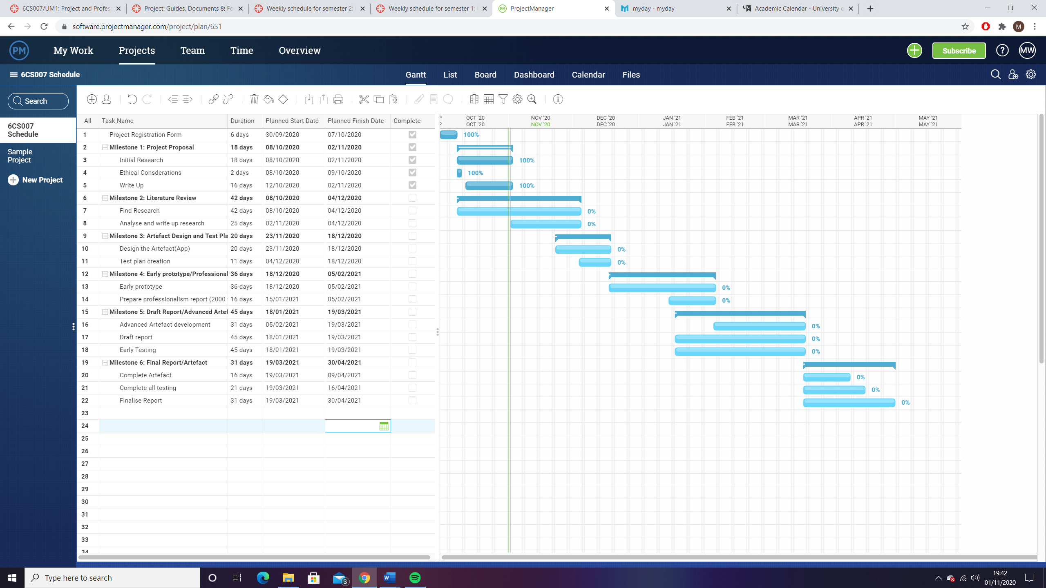

## 3.5 References and Bibliography

Apple.com. (2019). *Swift - Apple Developer*. [online] Available at: <https://developer.apple.com/swift/>. [Accessed 22nd October 2020].

Android Developers. (2019). *Build your first app  |  Android Developers*. [online] Available at: <https://developer.android.com/training/basics/firstapp>. [Accessed 22nd October 2020].

Android Developers. (2019). *SpeechRecognizer | Android Developers*. [online] Available at: <https://developer.android.com/reference/android/speech/SpeechRecognizer>. [Accessed 23rd October 2020].

Berger, S.M. and Ludwig, T.D. (2007). Reducing Warehouse Employee Errors Using Voice-Assisted Technology That Provided Immediate Feedback. *Journal of Organizational Behavior Management*, 27(1), pp.1–31.

Cahill, S., Macijauskiene, J., Nygård, A.-M., Faulkner, J.-P. and Hagen, I. (2007). Technology in dementia care. *Technology and Disability*, 19(2–3), pp.55–60.

Elfaki, A. and Alotaibi, M. (2018). The role of M-health applications in the fight against Alzheimer’s: current and future directions. *mHealth*, 4, pp.32-32.

Flutter.dev. (2019). *Flutter - Beautiful native apps in record time*. [online] Available at: <https://flutter.dev/>. [Accessed 21st October 2020].

ProgramMe Programming (2015). *Learn Android Application Development*. [online] Udemy. Available at: <https://www.udemy.com/course/learn-android-application-development-y/>. [Accessed 25th October 2020].

Sergio Licea. 2020. *Reminder, Reminder with Calendar and Voice Reminders* (3.8). [Mobile App]. [Accessed 31st October 2020].

Thomas Tsopanakis. 2020. *Lists To Do* (2.3.8).[Mobile App]. [Accessed 31st October 2020].

Venkatesh, Thong and Xu (2012). Consumer Acceptance and Use of Information Technology: Extending the Unified Theory of Acceptance and Use of Technology. *MIS Quarterly*, 36(1), p.157.

Wahlheim, C.N., Smith, W.G. and Delaney, P.F. (2019). Reminders can enhance or impair episodic memory updating: a memory-for-change perspective. *Memory*, 27(6), pp.849–867.

‌

‌

# Section 4: Additional Sources of Information

## 4.1 Ethical Considerations Form

**UNIVERSITY OF WOLVERHAMPTON**

**SCHOOL OF TECHNOLOGY**

**ETHICAL CONSIDERATION FOR STUDENTS STUDYING TAUGHT PROGRAMMES**

|  |  |  |  |
| --- | --- | --- | --- |
| **Section 1: Your details** | | | |
| **First Name & Surname:** | Matthew Ward | **Student No:** | 1802599 |
| **Course:** | BSc (Hons) Computer Science | | |
| **Project Title** | Augmented Memory Mobile App | | |
| **Supervisor:** | Jeffery Ting | | |

|  |  |
| --- | --- |
| **Section 2: Your Project Topic** | |
| **2.1** What problem is this project addressing? (100 words or less) | This project will be tackling creating an app to help create reminders using the users voice. This app in particular will be designed keeping those suffering from memory condition, effects of old age as well as effects such as dementia and Alzheimer’s in the early stages to assist them in creating daily plans and reminders. |
| **2.2** Will information or artefact resulting from your project be available externally to the University? | Yes |
| **2.2.1**  **If you answered ‘yes’ to 2.2,**  Will any such information place anyone at risk or possibly result in any action that might be detrimental to their wellbeing? (See guidelines) | No |
| **2.2.2**  In what format will the information or artefact be made available? | Either an app on Google Play Store (if the university allows this) or a zipped project file which can be loaded with Android Studio |

|  |  |
| --- | --- |
| **Section 3: Method of Data Collection** | |
| **Please attach samples with this form if you intend to do interviews, surveys, or questionnaires.** | |
| **3.1** Does any part of your proposed project involve human participants?  If No go to Section 4. | Yes |
| **3.1.1**  **If you answered ‘yes’ to 3.1,**  Is the sole involvement of human participants in order to provide opinions to support the specification or testing of an artefact to be produced as an outcome of the project? | Yes |
| **3.1.2**  **If you answered ‘yes’ to 3.1.1,**  Does this artefact/information have any characteristics which might be detrimental to the wellbeing of any human participants in your project? If so, explain. | No – Testing will be mostly limited to design of the app and adding functionality as well as opinions. |
| **3.2**  **If you answered ‘yes’ to 3.1,**  Are there other ways you might meet your project aims without involving human participants? If not, why?  If yes discuss with your Supervisor how you will achieve this and go to section 4. | N/A |
| **3.2.1**  How will you select your participants? | From mixed age groups, family, friends, supervisor and other university students. |
| **3.2.2**  How many participants will you contact? | Unknown |
| **3.2.3**  How will you approach potential participants? E.g. email, letter, face to face? | Text, Email, Microsoft Teams |
| **3.2.4**  Are your participants adults? (over 18 and competent to give consent) If no, answer 3.2.5 | Yes |
| **3.2.5**  Are your participants children or adults over 18 and not competent to give consent? If yes, why is it necessary to involve these participants? (See guidelines)  Explain how you will ensure parental/guardian consent. | No |
| **3.2.6**  Are you offering any incentives to any of your participants, financial or otherwise? (See guidelines) | No |
| **3.2.7**  How much time do you estimate will be needed from any participants? (See guidelines) | Unknown, initial contact to gather opinions, further contact to test the application |
| **3.2.8**  Please list the method of data collection and analysis intended to be used | Analysing their opinions to the developing app through weekly messages or potentially a weekly survey to be given to participants to gather feedback. |
| **3.2.9**  Will all of the data collected contribute towards your results? | Yes – All data will contribute towards creation and development of the app. No unnecessary data will be collected. |

|  |  |
| --- | --- |
| **Section 4: Confidentiality and data handling** | |
| **Please read methods of ensuring confidentiality in the guidelines.** | |
| **4.1** Will you ensure the anonymity of data collected from/and about participants? | Yes |
| **4.2** Will you store/protect data collected from individuals e.g. password protected files? | No – Only data collected opinions for development. App storage is done on their own device. |
| **4.3** Once your project is complete and information is no longer needed, will you destroy your data? | Yes – This excludes any surveys/data placed in the final report. |
| **4.4** Will anyone else have access to the data collected? | Yes – The university through the report. |
| **If so,**  (i) please name the individuals and/or groups that will have access;  (ii) why is access being given to those listed in (i)? | University of Wolverhampton  It is required by the university to show the necessary testing is being conducted. |

|  |  |
| --- | --- |
| **Section 5: Working with other parties and companies** | |
| **5.1** Will you be using data on subjects held by another party or organisation? | No |
| **If Yes,**  (i) Please give details.  (ii) How will you gain access to this information? | N/A |
| **5.2** Do you require written permission from a company, organisation or location, e.g. an employer or local authority? | No |
| **If Yes,**  (i) Please complete an external agreement form and include this with your submission. | N/A |
| **NB: If working with another organisation or company please familiarise yourself with their Health & Safety procedures.** | |

**Things you must be aware of:**

**Data Protection Act**: <http://www.ico.gov.uk/what_we_cover/data_protection.aspx>

**Freedom of Information Act**: <http://www.opsi.gov.uk/Acts/acts2000/ukpga_20000036_en_1>

[University of Wolverhampton Ethical Approval Procedural Guidelines](http://www.wlv.ac.uk/PDF/aca-pols-ethics-scrutiny.pdf)

**Checklist:**

1. If you are using a questionnaire or interview sheet please include a list of sample questions with your submission.

2. In addition, please include an introductory cover letter stating some information about you, your project proposal and how your data will be used.

3. If you are undertaking a project involving a company or organisation you will need to show that you have approval from that organisation. Please include a completed copy of the External Agreement Form.

## 4.2 Resources

For this task some resources will be required. The use of Android Studio and relevant API’s, as well as a one-time purchase of a Developer Account (purchased by myself) to release this app on the Google Play Store if the University permits.

## 4.3 Client

The supervisor Jeffery Ting will be the client for this project.